FSDI 107 – Assignment 3
Name: Charles Taggart
Theme: Organika Store – Show Catalog
GitHub Pages Link: https://github.com/chucktagg83/project107.git
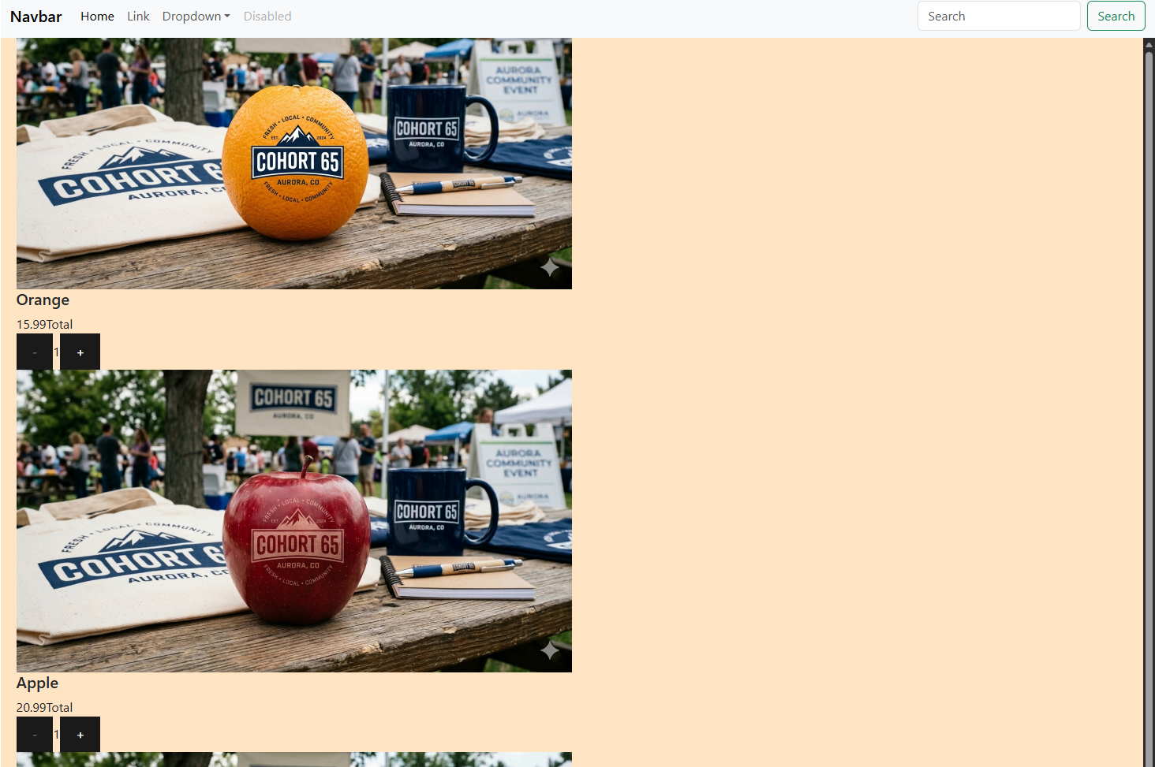

Summary of Edits:
- Added css / page scroll capabilities.
- Displays product tags
- Displays a unique image and title of each product
- Also below is the responsiveness shown.